Intro to Mega:bit

Hi teachers! We are a group of Imperial students working on Mega:bit which is basically a bigger version of the micro:bit on which students can plug in their microbit and show their work on the LEDs of the Mega:bit.

Hi teachers! We are a group of Imperial students working on Mega:bit which is basically a bigger version of the micro:bit for demonstration purposes. Students can plug their micro:bit onto the mega:bit so that their work can be shown to the whole class easily.

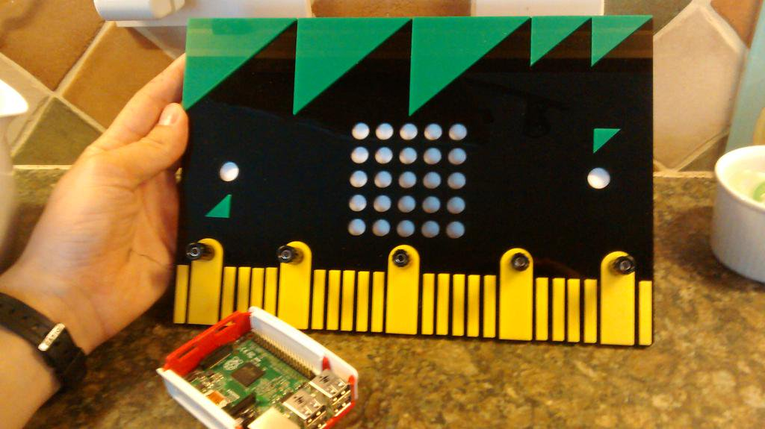

Do you think having a Mega:bit for demonstration of students’ code to the class would be helpful?\*

\*Mega:bit is a bigger version of the micro:bit on which students can plug in their microbit and show their work on the LEDs of the Mega:bit.

What features would you expect from the Mega:bit?

If you had a Mega:bit, would it be preferable for you to hold it in front or at the side?

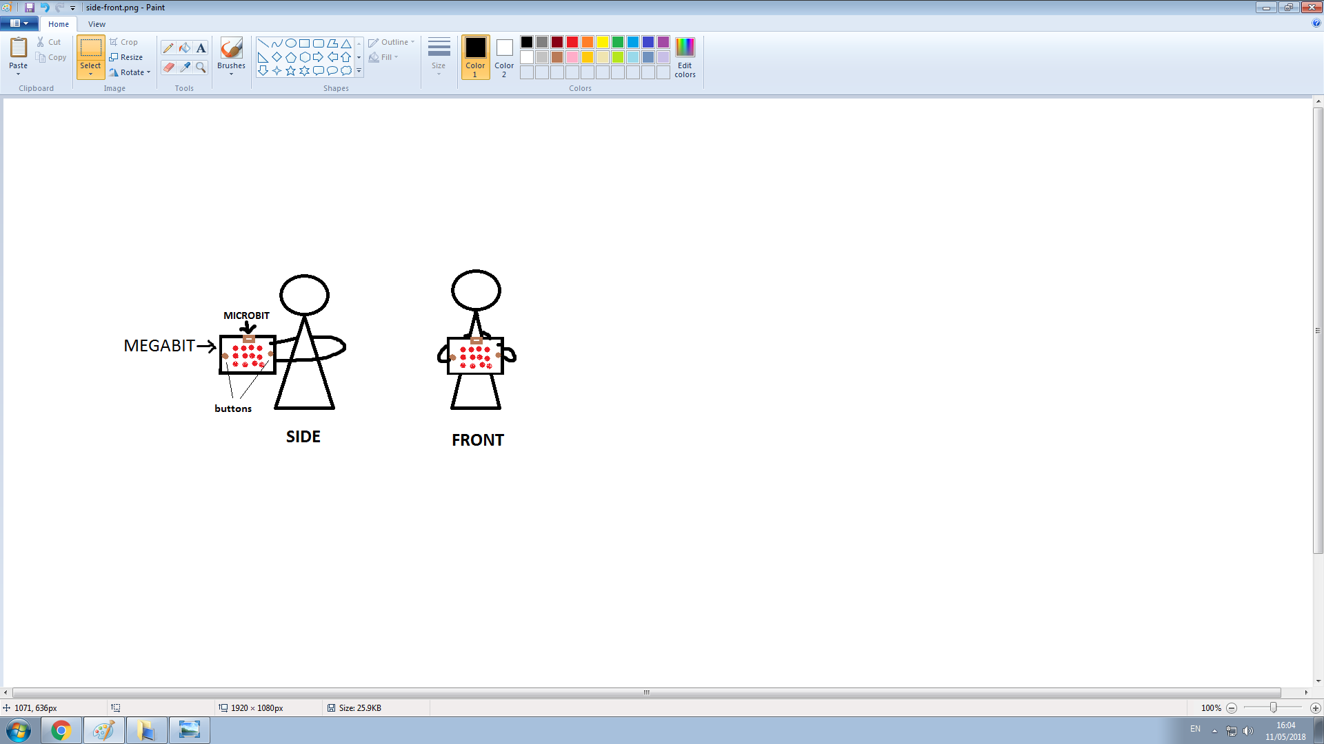

If you prefer holding the Mega:bit in front, how useful/helpful would having LEDs at the back be?

Would you have a preference on batteries (I.e. USB power supply [portable batteries], AA batteries, rechargeable lithium batteries...)?

Which option would you choose for the location of the buttons?

1. At the front face of the Mega:bit (same position as the Micro:bit)
2. At the back but with an indicator in the front to show students which button is pressed

How big should it be?

-About A4 size

-

<https://docs.google.com/forms/d/e/1FAIpQLSeVRwZyqfOpxLcQNXQh7lcv9uSoPuKQ7lq_mb9wanPwTjpQ_A/viewform?usp=sf_link>